BEACONHOUSE NATIONAL UNIVERSITY
School of Computer & Information Technology
LAB ASSIGNMENT 3
DNS & Web Server Configuration
Built from Scratch — Cisco Packet Tracer

Course | Computer Networks Lab (Lab-209)
Semester | Spring 2026
Institution | Beaconhouse National University
Instructor | Shazia Rizwan
Lab Instructor | Hasnain Ahmad
Total Marks | 20 Marks
CLOs Covered | CLO 4 (Apply — C3)
Submission | Submit .pkt file + screenshots via LMS

Student Name: Saad Mughal Roll No: F2023-009 Section: C

1. Learning Objectives
By the end of this lab, you will be able to:
- Build a multi-device network topology from scratch in Cisco Packet Tracer
- Configure a Server-PT as a combined DNS and Web server for youtube.com
- Set up an INTERNET router to interconnect the server and the campus network
- Configure R1 with interface IPs, a default route, a DNS server entry, and local ip host records
- Set PC1, PC2, and PC3 to use the external DNS server for hostname resolution
- Ping remote devices by hostname instead of IP from both R1 and the PCs
- Use Simulation Mode to inspect DNS Query and DNS Reply packets step by step

Mapped CLO: CLO 4 — Configure network services in Cisco Packet Tracer [Apply — Bloom's C3]

2. Background
In this lab, Server-PT at 1.1.1.1 does two jobs at once: it is the DNS server that resolves youtube.com, and it is the web server that serves the youtube.com web page. When a PC types youtube.com in a browser, it first asks 1.1.1.1 for the IP, then contacts that IP to load the page — all within the same server.

Concept | Explanation
DNS Server | Stores hostname-to-IP mappings (A records). When queried with 'youtube.com', it returns the IP of the server hosting that site.
A Record | A DNS record mapping a hostname to an IPv4 address. In this lab: youtube.com → 1.1.1.1 (since the same server hosts both DNS and the web page).
Web Server (HTTP) | Runs HTTP service on port 80. Serves web pages when a client sends an HTTP GET request. Server-PT has a built-in HTTP service.
Default Route | A catch-all route (0.0.0.0/0) on R1. Any packet destined for the internet (e.g. 1.1.1.1) is forwarded via this route toward the INTERNET router.
ip name-server | Cisco IOS command that sets which DNS server the router itself uses. R1 will query 1.1.1.1 for names it cannot resolve locally.
ip host | Cisco IOS command that creates a static local hostname-to-IP mapping on the router — like a local hosts file. Used for R1, PC1, PC2, PC3.
Simulation Mode | Pauses Packet Tracer's real-time mode so you can step through each packet and inspect DNS query/reply contents in detail.

3. Lab Topology
The topology below shows exactly what you will build. Study every interface label and IP address before starting.

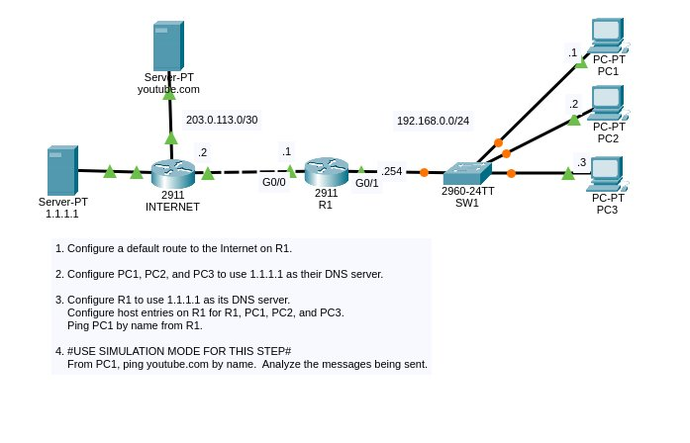
Figure 1 — DNS & Web Server Lab Topology

3.1 IP Address Plan
Device | Interface | IP Address | Subnet Mask | Notes
Server-PT (youtube.com / DNS) | NIC | 1.1.1.1 | 255.255.255.0 | DNS + Web server — same device
INTERNET Router | G0/0 | 203.0.113.2 | 255.255.255.252 | Faces R1 on /30 WAN link (.2 side)
INTERNET Router | G0/1 | 1.1.1.254 | 255.255.255.0 | Faces Server-PT
R1 | G0/0 | 203.0.113.1 | 255.255.255.252 | Faces INTERNET Router (.1 side)
R1 | G0/1 | 192.168.0.254 | 255.255.255.0 | LAN gateway for PCs
SW1 | — | — | — | Layer-2 switch, no IP needed
PC1 | NIC | 192.168.0.1 | 255.255.255.0 | GW: 192.168.0.254 DNS: 1.1.1.1
PC2 | NIC | 192.168.0.2 | 255.255.255.0 | GW: 192.168.0.254 DNS: 1.1.1.1
PC3 | NIC | 192.168.0.3 | 255.255.255.0 | GW: 192.168.0.254 DNS: 1.1.1.1

⚠️ Note Read the topology image carefully. The WAN link between INTERNET and R1 is 203.0.113.0/30. The INTERNET router takes .2 and R1 takes .1 on that link — note this is the reverse of a typical setup, so follow the diagram exactly.

3.2 Devices to Place in Packet Tracer
Device Type | Model | Qty | Label in Workspace
Router | 2911 | 2 | INTERNET, R1
Switch | 2960-24TT | 1 | SW1
Server | Server-PT | 1 | Server-PT (labelled: youtube.com / 1.1.1.1)
PC | PC-PT | 3 | PC1, PC2, PC3

3.3 Cable Connections
From | Port | To | Port | Cable Type
Server-PT | FastEthernet0 | INTERNET Router | GigabitEthernet0/1 | Straight-Through
INTERNET Router | GigabitEthernet0/0 | R1 | GigabitEthernet0/0 | Straight-Through
R1 | GigabitEthernet0/1 | SW1 | GigabitEthernet0/1 | Straight-Through
SW1 | FastEthernet0/1 | PC1 | FastEthernet0 | Straight-Through
SW1 | FastEthernet0/2 | PC2 | FastEthernet0 | Straight-Through
SW1 | FastEthernet0/3 | PC3 | FastEthernet0 | Straight-Through

💡 Tip After placing all cables, wait a few seconds for the orange link lights to turn green before configuring anything. If a link stays orange, check the port selection.

4. Building the Network from Scratch
Configure every device in the order given below. Each device must be fully set up before moving to the next.

Device 1 — Configure Server-PT (DNS + Web Server)

Server-PT performs two roles simultaneously: it is the DNS server that holds the youtube.com A record, and it is the HTTP web server that delivers the youtube.com web page. Its IP (1.1.1.1) is the address that PCs and R1 will use as their DNS server.

Step 1.1 — Assign Static IP
- Click on Server-PT to open it.
- Go to Desktop → IP Configuration → select Static.
- Enter the following values:

Field | Value
IP Address | 1.1.1.1
Subnet Mask | 255.255.255.0
Default Gateway | 1.1.1.254
DNS Server | 1.1.1.1 (itself)

Step 1.2 — Enable DNS Service and Add A Record
- Click the Services tab → click DNS in the left panel.
- Toggle DNS Service to ON.
- Fill in the record fields and click Add:

Field | Value
Name | youtube.com
Type | A Record
Address | 1.1.1.1 (Server-PT's own IP — it hosts the web page too)

✅ Expected Result After clicking Add, you should see youtube.com listed in the DNS records table with address 1.1.1.1. This means: when any client asks 'where is youtube.com?', the server answers '1.1.1.1'.

Step 1.3 — Enable HTTP Web Service and Customise the Page
- Still on Server-PT → Services tab → click HTTP in the left panel.
- Confirm HTTP is ON.
- Click the edit button next to index.html and replace the page content with something recognisable, for example:

<html>
<body>
<h1>Welcome to YouTube - BNU SCIT Lab Simulation</h1>
<p>You have successfully resolved youtube.com via DNS.</p>
</body>
</html>

- Click Save after editing.

✅ Expected Result With both DNS and HTTP enabled on the same server, a PC that resolves youtube.com gets 1.1.1.1 back, then sends an HTTP request to 1.1.1.1, and receives this web page.

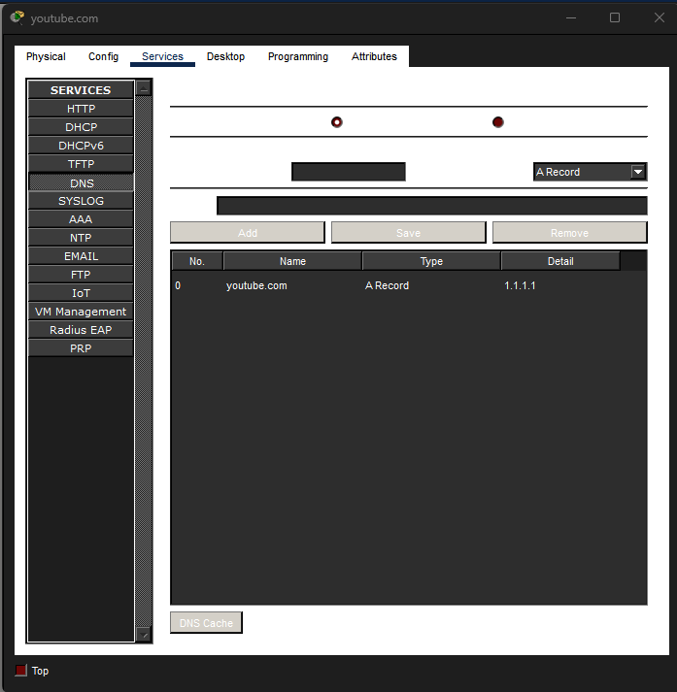

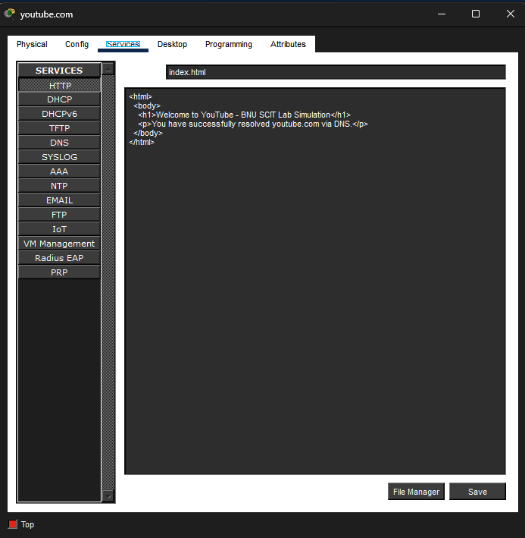

Device 2 — Configure the INTERNET Router (2911)

The INTERNET router connects Server-PT to R1. It has two interfaces: G0/1 faces Server-PT on the 1.1.1.0/24 network, and G0/0 faces R1 on the 203.0.113.0/30 WAN link. It also needs a static route back to the campus LAN so that reply packets can reach the PCs.

Step 2.1 — Configure Interfaces
! Open INTERNET router CLI and enter config mode
Router> enable
Router# configure terminal
Router(config)# hostname INTERNET

! G0/1 faces Server-PT (1.1.1.0/24 network)
INTERNET(config)# interface GigabitEthernet0/1
INTERNET(config-if)# ip address 1.1.1.254 255.255.255.0
INTERNET(config-if)# no shutdown
INTERNET(config-if)# exit

! G0/0 faces R1 on the 203.0.113.0/30 WAN link (.2 side per topology)
INTERNET(config)# interface GigabitEthernet0/0
INTERNET(config-if)# ip address 203.0.113.2 255.255.255.252
INTERNET(config-if)# no shutdown
INTERNET(config-if)# exit

! Static route back to campus LAN so DNS replies can reach the PCs
INTERNET(config)# ip route 192.168.0.0 255.255.255.0 203.0.113.1

INTERNET(config)# end
INTERNET# write memory

Step 2.2 — Verify INTERNET Router
! Confirm both interfaces are up/up
INTERNET# show ip interface brief

! Should show: 2 connected routes + 1 static route to 192.168.0.0/24
INTERNET# show ip route

! Ping Server-PT to confirm G0/1 side is working
INTERNET# ping 1.1.1.1

✅ Expected Result Both GigabitEthernet interfaces should appear as 'up/up' with their correct IPs. The ping to 1.1.1.1 must succeed before proceeding.

Device 3 — Configure R1 (Campus Router)

R1 is the most important device to configure correctly. It connects the campus LAN to the internet-side. It also acts as a local DNS resolver — holding static host entries for R1, PC1, PC2, and PC3 — and forwards any other DNS queries upstream to 1.1.1.1.

Step 3.1 — Configure Interfaces
! Enter R1 CLI
Router> enable
Router# configure terminal
Router(config)# hostname R1

! G0/0 — WAN interface toward INTERNET router (.1 side of 203.0.113.0/30)
R1(config)# interface GigabitEthernet0/0
R1(config-if)# ip address 203.0.113.1 255.255.255.252
R1(config-if)# no shutdown
R1(config-if)# exit

! G0/1 — LAN interface — default gateway for PC1, PC2, PC3
R1(config)# interface GigabitEthernet0/1
R1(config-if)# ip address 192.168.0.254 255.255.255.0
R1(config-if)# no shutdown
R1(config-if)# exit

Step 3.2 — Configure Default Route
! Send all unknown traffic (internet-bound) toward INTERNET router
! Next hop = 203.0.113.2 (INTERNET router's G0/0 IP)
R1(config)# ip route 0.0.0.0 0.0.0.0 203.0.113.2

⚠️ Note The next-hop IP for R1's default route is 203.0.113.2 — the INTERNET router's G0/0 address. Do not use 203.0.113.1 (that is R1's own G0/0).

Step 3.3 — Configure DNS Server on R1
! Tell R1 which DNS server to use when it resolves names itself
R1(config)# ip name-server 1.1.1.1

! Ensure DNS lookups are enabled on R1 (sometimes disabled by default)
R1(config)# ip domain-lookup

Step 3.4 — Create Local Host Entries on R1
Host entries (ip host) create a local hostname-to-IP table on R1. When R1 or anything that uses R1 as a DNS resolver asks for PC1, PC2, PC3, or R1 by name, the router answers immediately from this local table without querying 1.1.1.1.

! Local A record for R1 itself (WAN IP and LAN IP both registered)
R1(config)# ip host R1 203.0.113.1 192.168.0.254

! Local A record for PC1
R1(config)# ip host PC1 192.168.0.1

! Local A record for PC2
R1(config)# ip host PC2 192.168.0.2

! Local A record for PC3
R1(config)# ip host PC3 192.168.0.3

R1(config)# end
R1# write memory

Step 3.5 — Verify R1 Full Configuration
! Check all interfaces are up/up with correct IPs
R1# show ip interface brief

! Routing table: should show S* default + 2 directly connected routes
R1# show ip route

! View all local host entries
R1# show hosts

! Ping INTERNET router WAN IP — tests default route
R1# ping 203.0.113.2

! Ping Server-PT — tests full routing through INTERNET router
R1# ping 1.1.1.1

! Ping PC1 by hostname — tests local ip host entry
R1# ping PC1

! Ping PC2 and PC3 by hostname
R1# ping PC2
R1# ping PC3

! Resolve youtube.com from R1 — tests DNS query to 1.1.1.1
R1# ping youtube.com

✅ Expected Result All pings must succeed. 'show hosts' should list R1, PC1, PC2, PC3 as permanent (perm) entries. 'ping youtube.com' from R1 will cause R1 to query 1.1.1.1, get 1.1.1.1 back (A record), and ping it — confirming end-to-end DNS and routing.

Device 4 — Configure PC1, PC2, and PC3

Each PC needs a static IP address, the correct default gateway (R1's G0/1), and DNS server set to 1.1.1.1 (Server-PT). Without the correct DNS entry, pinging or browsing by hostname will fail even if routing works perfectly.

Step 4.1 — Configure Each PC
- Click on PC1 → Desktop tab → IP Configuration → select Static.
- Enter the values for PC1 from the table below.
- Repeat for PC2 and PC3 with their respective IPs.

PC | IP Address | Subnet Mask | Default Gateway | DNS Server
PC1 | 192.168.0.1 | 255.255.255.0 | 192.168.0.254 | 1.1.1.1
PC2 | 192.168.0.2 | 255.255.255.0 | 192.168.0.254 | 1.1.1.1
PC3 | 192.168.0.3 | 255.255.255.0 | 192.168.0.254 | 1.1.1.1

💡 Tip Configure all three PCs before moving to the task section. You can copy the settings for PC2 and PC3 from PC1, changing only the last octet of the IP address.

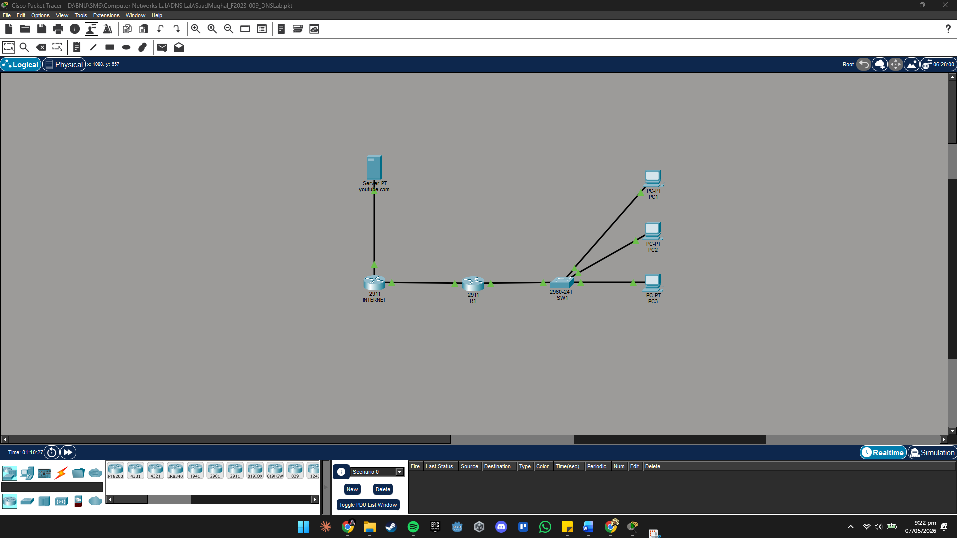

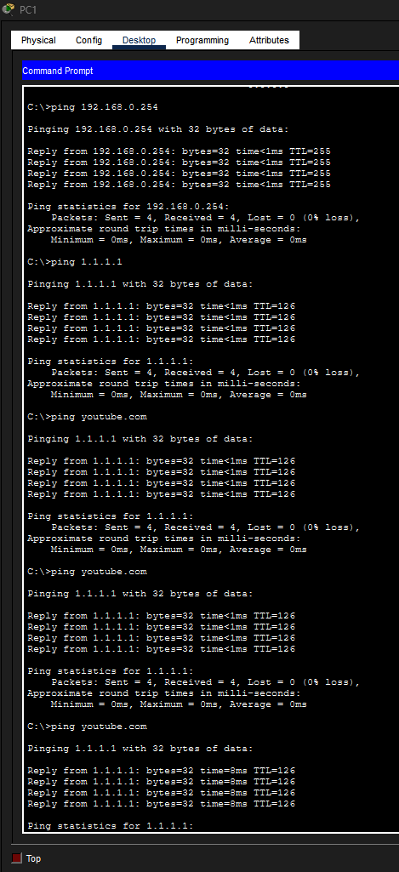
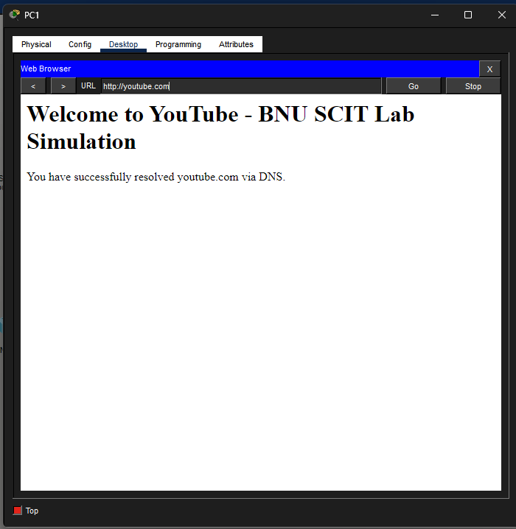

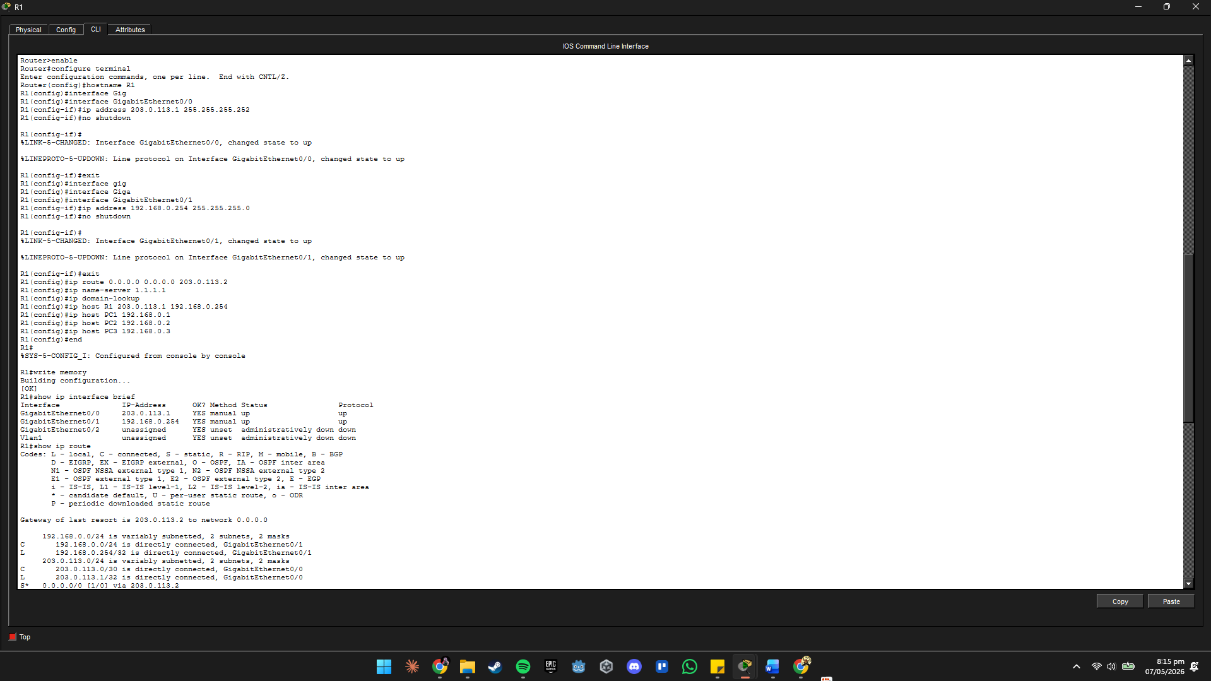

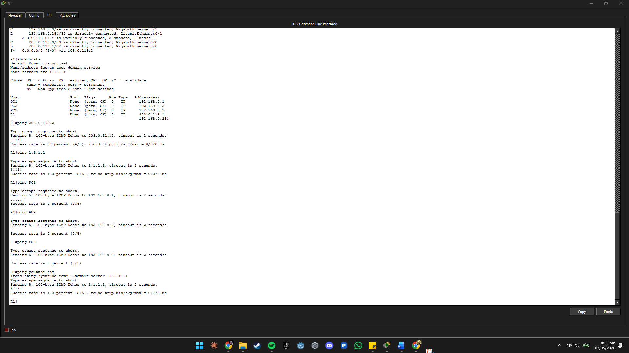

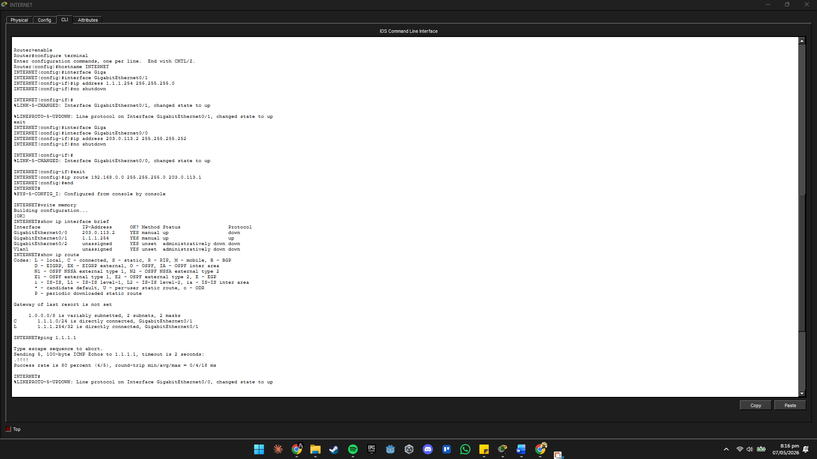

5. Lab Tasks
Now that all devices are configured, execute the following 4 tasks in order. Each task corresponds directly to the steps listed in the lab assignment brief.

Task 1 — Verify Default Route to the Internet on R1

CLO Mapped: CLO 4 — Configure network services in Cisco Packet Tracer [Apply — C3]
The default route was already configured in Device 3 Step 3.2. This task verifies it is correct and that it enables traffic from R1 to reach Server-PT on the internet side.

! On R1 — verify the default route exists in the routing table
R1# show ip route

! Look for this line in the output:
S* 0.0.0.0/0 [1/0] via 203.0.113.2

! Verify end-to-end reachability from R1 to Server-PT
R1# ping 1.1.1.1

! Expected output:
!!!!!
Success rate is 100 percent (5/5)

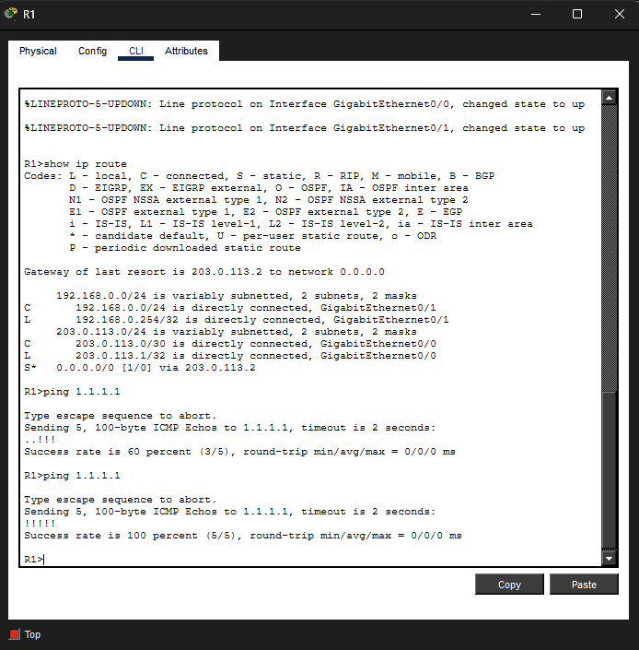

✅ Expected Result The S* line confirms the default route is in place. Five exclamation marks in the ping output confirm R1 can reach Server-PT across the INTERNET router.

⚠️ Note If the ping fails, check: (1) Both INTERNET router interfaces are up/up. (2) The static route on INTERNET router points back to 192.168.0.0/24 via 203.0.113.1. (3) R1's G0/0 IP is 203.0.113.1 (not .2).

📝 Task 1 Question
Copy the full S* line from 'show ip route' on R1 here:
S* Entry: _S* 0.0.0.0/0 [1/0] via 203.0.113.2______

What does the [1/0] value mean in the routing table output?
Answer: Administrative Distance (AD) = 1 means it is a static route (AD of 1 is the default for static routes, making them highly preferred over dynamic routes). Metric = 0 means there is no hop-count or cost-based metric associated, the router simply follows the next-hop IP address 203.0.113.2 without any additional calculation_______________________________________________________________

Task 2 — Verify PC1, PC2, PC3 Use 1.1.1.1 as DNS and Can Ping by Name

CLO Mapped: CLO 4 — Configure network services in Cisco Packet Tracer [Apply — C3]
DNS was set on each PC in Device 4. Now verify it is working by confirming the settings and testing name resolution from the PCs.

Verify DNS is Configured on Each PC
- Click on PC1 → Desktop → IP Configuration.
- Confirm DNS Server shows 1.1.1.1. Take a screenshot.
- Repeat for PC2 and PC3.

Test Name Resolution from PC1
- Click PC1 → Desktop → Command Prompt. Run the following:

! Confirm PC1's full IP configuration
C:\> ipconfig

! Ping the default gateway (R1) by IP — confirms basic LAN connectivity
C:\> ping 192.168.0.254

! Ping Server-PT by IP — confirms routing to internet side works
C:\> ping 1.1.1.1

! Ping youtube.com by NAME — this is the key DNS test
! PC1 will query 1.1.1.1 first, get back 1.1.1.1, then ping it
C:\> ping youtube.com
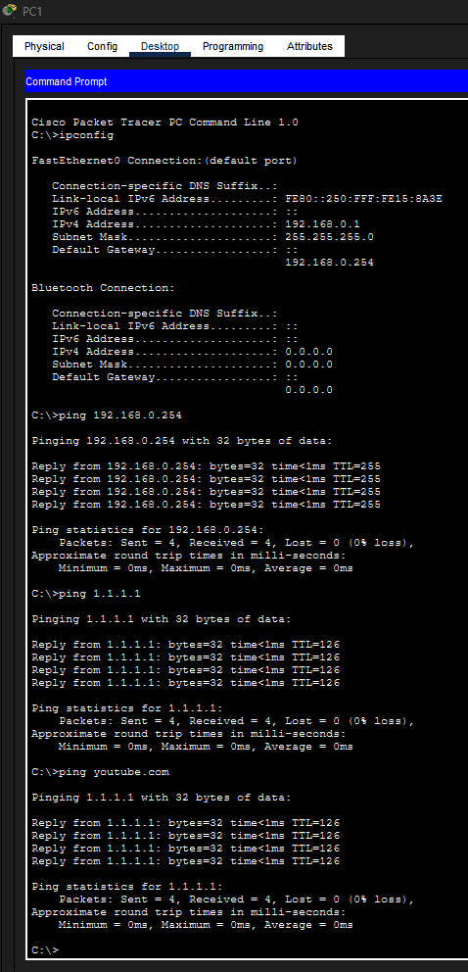
✅ Expected Result The ping youtube.com output should show: 'Pinging youtube.com [1.1.1.1]' confirming DNS resolved the name. Then 4 successful replies. Repeat the same ping from PC2 and PC3 — all should succeed.

🔧 Try It Yourself Open a web browser on PC1: Desktop → Web Browser. Type http://youtube.com in the URL bar and press Go. The custom page you configured on Server-PT should appear. This confirms full DNS + HTTP flow.

📝 Task 2 Question
What IP address was returned when PC1 pinged youtube.com by name?
Resolved IP: ___ Resolved IP: 1.1.1.1_____

Did all three PCs (PC1, PC2, PC3) successfully resolve and ping youtube.com?
PC1: Yes PC2: Yes PC3: Yes

Did the web browser on PC1 load the youtube.com page? Describe what you saw:
Answer: The page displayed: 'Welcome to YouTube - BNU SCIT Lab Simulation' as a large heading, followed by the paragraph 'You have successfully resolved youtube.com via DNS.' This confirmed that PC1 sent an HTTP GET request to 1.1.1.1 (after DNS resolved youtube.com to that IP), and Server-PT responded with the custom index.html page.

Task 3 — Verify R1 Uses 1.1.1.1 as DNS and Host Entries Work

CLO Mapped: CLO 4 — Configure network services in Cisco Packet Tracer [Apply — C3]
The ip name-server and ip host entries were configured in Device 3. This task verifies that they are correct and that R1 can resolve both local hostnames (from its own ip host table) and external names (via DNS query to 1.1.1.1).

Verify the Host Table on R1
! Show all static host entries on R1
R1# show hosts

! Expected output — four entries all marked as 'perm' (permanent):
Host Port Flags Age Type Address(es)
R1 None (perm, OK) 0 IP 203.0.113.1 192.168.0.254
PC1 None (perm, OK) 0 IP 192.168.0.1
PC2 None (perm, OK) 0 IP 192.168.0.2
PC3 None (perm, OK) 0 IP 192.168.0.3

Ping Hosts by Name from R1
! Ping PC1 by hostname — R1 looks up its local ip host table
R1# ping PC1

! Ping PC2 and PC3 by hostname
R1# ping PC2
R1# ping PC3

! Also verify R1 can resolve external names via 1.1.1.1
R1# ping youtube.com
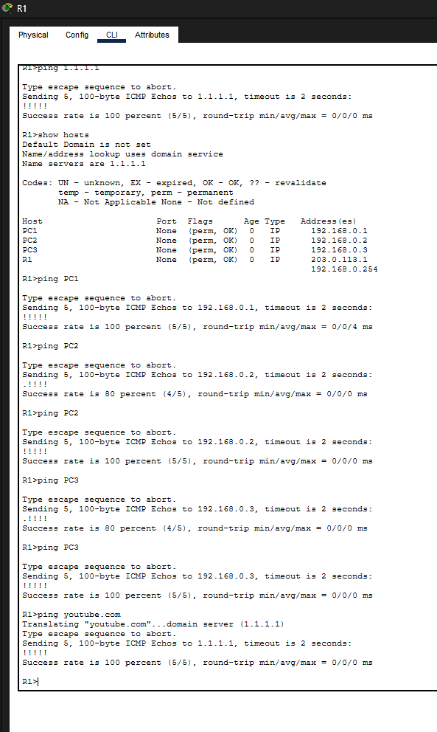
✅ Expected Result All four pings should return 5 successful replies. The 'ping PC1' confirms the local ip host entry is working. The 'ping youtube.com' confirms R1's dns query to 1.1.1.1 returns 1.1.1.1 and that the server is reachable.

⚠️ Note If 'ping PC1' fails, check the ip host entry was entered correctly. If 'ping youtube.com' fails, check 'ip name-server 1.1.1.1' is in the config ('show run | include name-server') and that 1.1.1.1 is reachable.

📝 Task 3 Question
Run 'show hosts' on R1. List all four host entries exactly as they appear:
1. R1 → 203.0.113.1 192.168.0.254 (perm, OK)
2. PC1 → 192.168.0.1 (perm, OK)
3. PC2 → 192.168.0.2 (perm, OK)
4. PC3 → 192.168.0.3 (perm, OK)

When R1 pings 'PC1' by name, does it send a DNS query to 1.1.1.1 first, or use its local ip host table? How do you know?
Answer: R1 uses its local ip host table, NOT a DNS query to 1.1.1.1.
Evidence: The 'show hosts' command shows PC1 listed with the flag 'perm' (permanent). This means the entry was statically configured via the 'ip host' command and is resolved locally. In Simulation Mode, no DNS UDP packet (port 53) would be generated when pinging PC1, the router resolves the name instantly from its own table without querying any external server. Cisco IOS always checks its local ip host table before sending a DNS query.

Task 4 — Ping youtube.com from PC1 and Analyse in Simulation Mode

CLO Mapped: CLO 4 — Configure network services in Cisco Packet Tracer [Apply — C3]
This is the most critical task. You will switch Packet Tracer to Simulation Mode and watch every packet involved when PC1 types 'ping youtube.com' — from the DNS query leaving PC1, to the DNS reply arriving back, to the ICMP ping reaching Server-PT.

Part A — Ping youtube.com by Name from PC1
- Click on PC1 → Desktop → Command Prompt.
- Type the following and press Enter:

! Ping youtube.com by name — this triggers a DNS lookup first
C:\> ping youtube.com

! Expected output:
Pinging youtube.com [1.1.1.1] with 32 bytes of data:
Reply from 1.1.1.1: bytes=32 time<1ms TTL=126
Reply from 1.1.1.1: bytes=32 time<1ms TTL=126
Reply from 1.1.1.1: bytes=32 time<1ms TTL=126
Reply from 1.1.1.1: bytes=32 time<1ms TTL=126

✅ Expected Result The brackets [1.1.1.1] after youtube.com confirm that DNS successfully resolved the name. The replies confirm end-to-end reachability through two routers.

Part B — Observe DNS Messages in Simulation Mode
🔬 Simulation Mode
1. In the bottom-right corner of Packet Tracer, click the Simulation tab (or press Shift+S).
2. In the Event List Filters section, click 'Show All / None' to clear everything.
3. Tick only these protocols: DNS | ICMP
4. Click on PC1 → Desktop → Command Prompt.
5. Type: ping youtube.com and press Enter.
6. Click 'Capture / Forward' (▶|) button one step at a time.
7. Click on each coloured envelope that appears on the topology.
8. In the PDU Information window, look at the Outbound PDU details.
9. Identify the DNS Query and DNS Reply packets by their protocol label.
10. Record what you see in the Task 4 Question box below.

What to Look for in Each Packet
Step | Protocol | Direction | What You Should See
1 | DNS (UDP 53) | PC1 → Server-PT | DNS Query: Source = 192.168.0.1, Dest = 1.1.1.1, Port 53, Question = 'youtube.com'
2 | DNS (UDP 53) | Server-PT → PC1 | DNS Reply: Answer section shows youtube.com A record → 1.1.1.1
3 | ICMP | PC1 → Server-PT | ICMP Echo Request: Dest = 1.1.1.1 (resolved IP from DNS)
4 | ICMP | Server-PT → PC1 | ICMP Echo Reply: Src = 1.1.1.1, confirming server received the ping

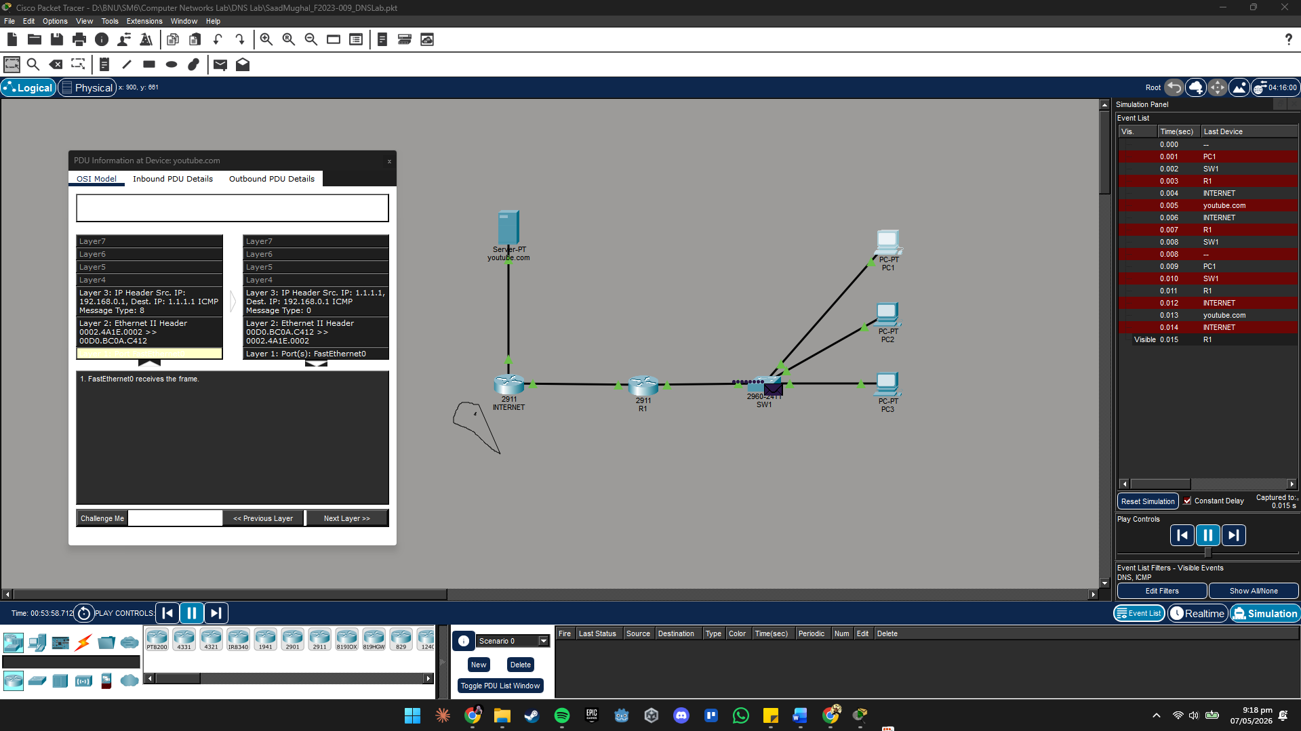

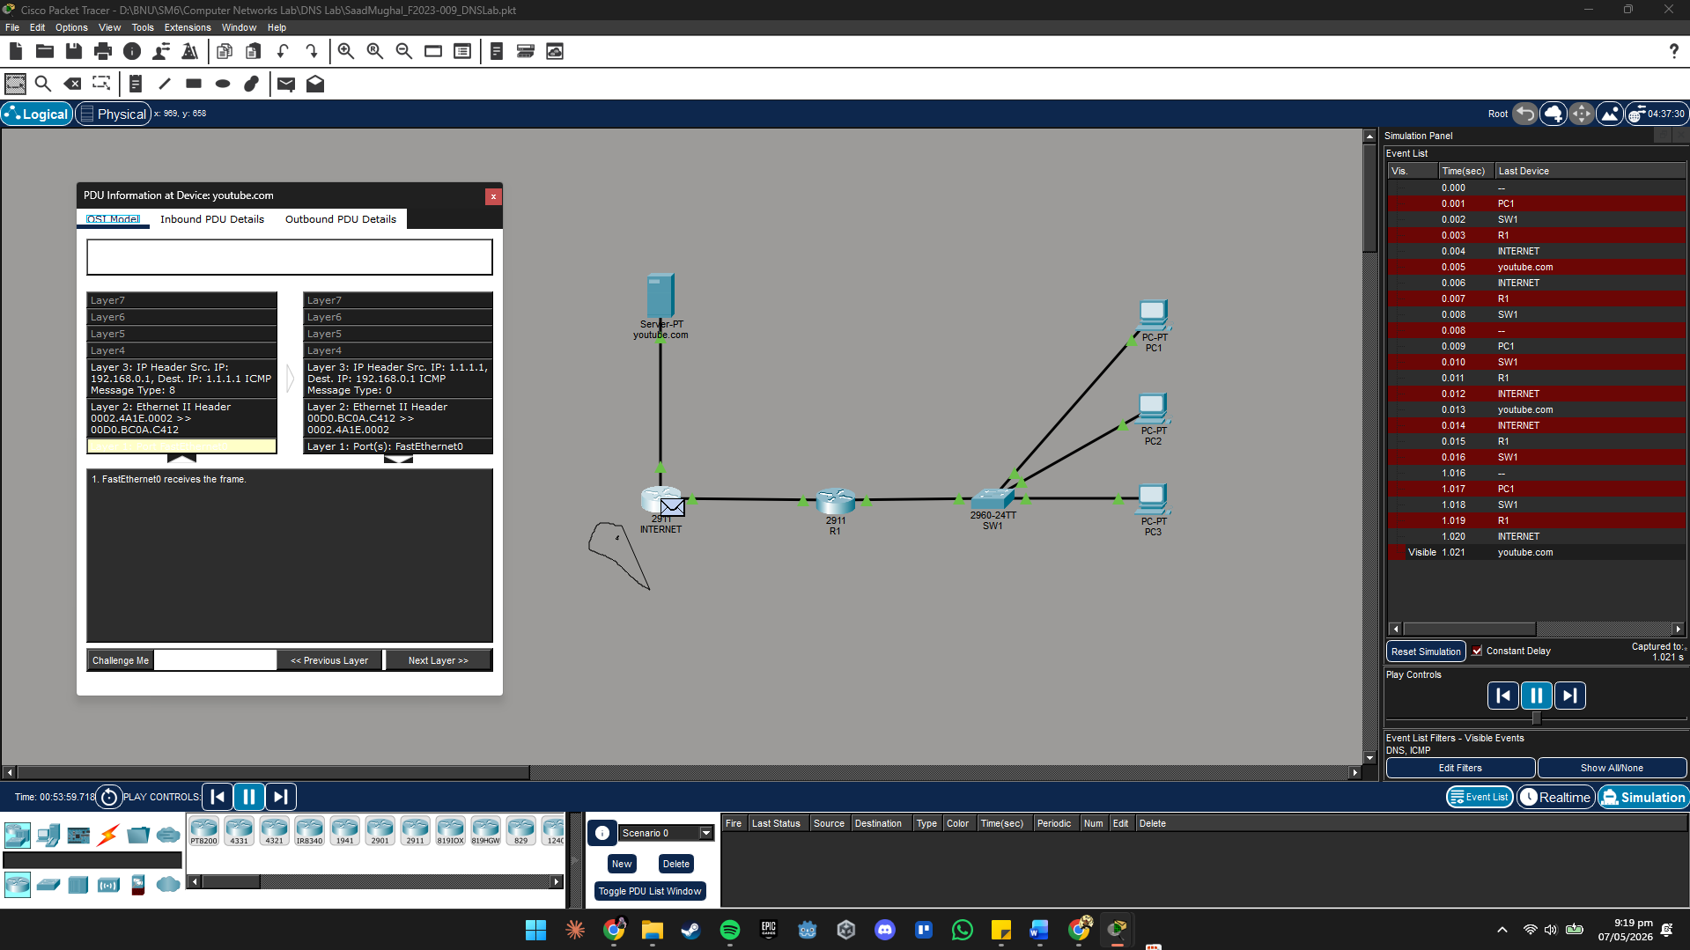

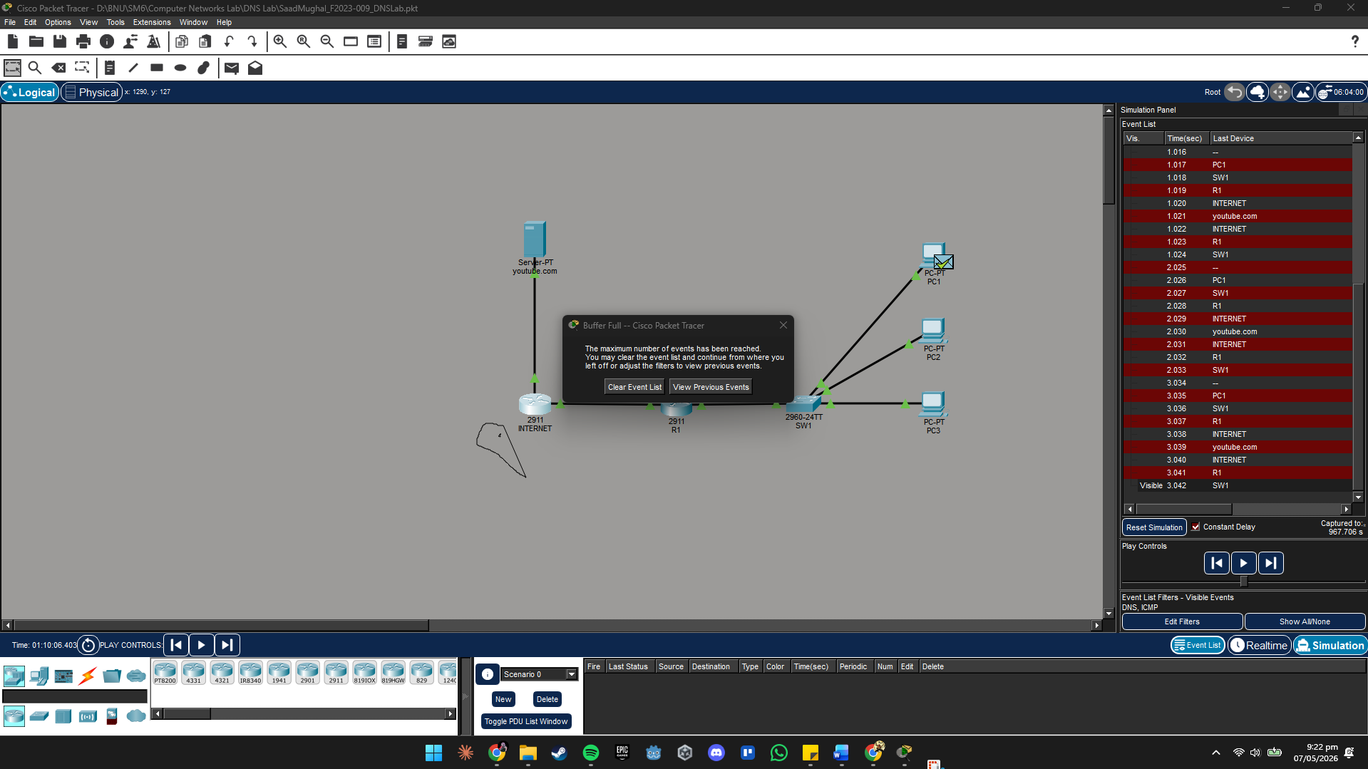

🔧 Try It Yourself In Simulation Mode, click on a DNS packet and open its PDU details. Navigate to the DNS layer and expand the 'Query' and 'Answer' sections. Screenshot this and include it in your submission.

📝 Task 4 Question
a) In the DNS Query PDU, what are the Source and Destination IP addresses?
Source IP:192.168.0.1 (PC1) Destination IP:1.1.1.1 (Server-PT / DNS Server)
Port: 53 (UDP - DNS uses port 53)

b) In the DNS Reply PDU, what hostname-to-IP mapping appears in the Answer section?
Hostname: youtube.com
Resolved IP: 1.1.1.1

c) After DNS resolved the name, what destination IP did the ICMP ping go to?
ICMP Destination IP: 1.1.1.1

d) Why does the DNS Query use UDP and not TCP? Explain in one sentence:
Answer: DNS queries use UDP because they are small, single-request/response exchanges that do not require the overhead of TCP's three-way handshake, connection management, or guaranteed delivery, UDP's speed makes it ideal for the short, low-latency lookups DNS performs on port 53.

e) If the INTERNET router did NOT have the static route back to 192.168.0.0/24,
what would happen to the DNS Reply packet? Why?
Answer: The DNS Reply packet from Server-PT (source: 1.1.1.1, destination: 192.168.0.1) would arrive at the INTERNET router on G0/1. However, without a route to 192.168.0.0/24, the INTERNET router's routing table would have no matching entry for 192.168.0.x. The packet would be dropped and the INTERNET router would send an 'ICMP Destination Unreachable' message back to Server-PT. PC1 would never receive the DNS Reply, meaning DNS name resolution would fail, and the subsequent ICMP ping to youtube.com would also never be triggered. This is exactly why the static route 'ip route 192.168.0.0 255.255.255.0 203.0.113.1' is required on the INTERNET router.

6. Deliverables & Submission
Submit all of the following via LMS before the deadline:

# | Deliverable | Details
1 | .pkt File | YourName_RollNo_DNSLab.pkt — fully working topology.
2 | Full Topology Screenshot | All 7 devices placed and labelled, all cables connected, all link lights green.
3 | Server-PT DNS Record Screenshot | Services → DNS tab showing youtube.com A record = 1.1.1.1.
4 | Server-PT HTTP Page Screenshot | Services → HTTP tab showing custom index.html content.
5 | INTERNET Router: show ip interface brief | Both interfaces up/up with correct IPs.
6 | INTERNET Router: show ip route | Showing 2 connected routes + static to 192.168.0.0/24.
7 | R1: show ip route | Showing S* default route + 2 connected routes.
8 | R1: show hosts | Showing all 4 permanent host entries (R1, PC1, PC2, PC3).
9 | R1: ping PC1 by name | Screenshot of 'ping PC1' from R1 CLI — must show 5 replies.
10 | PC1: all ping tests | Screenshot showing pings to 192.168.0.254, 1.1.1.1, and youtube.com.
11 | PC1: Web Browser | Screenshot of http://youtube.com loaded in PC1's Desktop Browser.
12 | Simulation Mode: DNS Query PDU | Screenshot of PDU details showing Src/Dst IP, port 53, query name.
13 | Simulation Mode: DNS Reply PDU | Screenshot of PDU Answer section showing youtube.com → 1.1.1.1.
14 | Completed Task Questions | All 4 task question boxes filled in on this document (this file).

⚠️ Note Submissions after the deadline will be penalised 50% per day. Identical .pkt files between students will be treated as plagiarism — automatic F grade per course policy.

7. Grading Rubric
Total: 20 Marks | CLO: CLO 4 — Configure network services in Cisco Packet Tracer [Bloom's Apply — C3]
Criterion | Marks | Full Marks  All criteria met | Partial  Minor errors | Needs Work  Major errors / missing
Server-PT Configuration (DNS + Web Server) | 4 | Correct IP (1.1.1.1/24, GW 1.1.1.254). DNS ON with youtube.com A record → 1.1.1.1. HTTP ON with custom page. Both screenshots provided. (4 marks) | One of DNS or HTTP correctly configured. IP correct but missing one service or A record points to wrong IP. (2–3 marks) | Server not configured or DNS/HTTP both off. A record missing or wrong. (0–1 mark)
INTERNET Router Configuration | 3 | Both interfaces up/up. IPs correct (G0/0: 203.0.113.2, G0/1: 1.1.1.254). Static route to 192.168.0.0/24 via 203.0.113.1 present. Ping to 1.1.1.1 succeeds. (3 marks) | Interfaces correct but static route missing, or one interface has wrong IP. (1–2 marks) | Router not configured or both interfaces down. (0 marks)
R1 Configuration (Interfaces, Route, DNS, Hosts) | 5 | G0/0 (203.0.113.1) and G0/1 (192.168.0.254) up/up. S* default route present. ip name-server 1.1.1.1 set. All 4 ip host entries in 'show hosts'. (5 marks) | Interfaces and route correct but 1–2 ip host entries missing, or ip name-server not set. (2–4 marks) | R1 interfaces missing IPs or default route absent. Host table empty. (0–1 mark)
Task 3 — Ping by Hostname from R1 | 3 | R1 pings PC1, PC2, PC3 by hostname — all succeed (5 replies each). R1 pings youtube.com successfully via DNS. Screenshots of CLI output provided. (3 marks) | 1–2 hostname pings succeed. youtube.com ping fails or missing screenshot. (1–2 marks) | All hostname pings fail or no CLI screenshots provided. (0 marks)
Task 4 — Simulation Mode Analysis | 3 | PC1 ping youtube.com shows resolved IP [1.1.1.1]. Simulation screenshots show DNS Query PDU (src/dst, port 53) and DNS Reply PDU (A record answer). Task 4 questions answered. (3 marks) | Ping youtube.com works but simulation screenshots missing key PDU details. Questions partially answered. (1–2 marks) | Ping by name fails or simulation mode not used. No PDU screenshots. (0 marks)
Task Questions & Understanding | 2 | All 4 task question boxes fully and correctly answered, in student's own words. Demonstrates clear understanding of DNS, routing, and simulation. (2 marks) | 2–3 question boxes answered correctly. Some answers vague or incomplete. (1 mark) | Fewer than 2 questions answered or mostly incorrect. (0 marks)
TOTAL | 20 Marks

8. CLO Mapping Summary

CLO | Description | Tasks Covered | Bloom's Level | Marks
CLO 4 | Configure network services in Cisco Packet Tracer | Tasks 1–4: Default route, DNS config, ip host entries, simulation analysis | Apply (C3) | 20 / 20

Query it, resolve it, browse it — that is how engineers learn.
Instructor: Shazia Rizwan | Lab Instructor: Hasnain Ahmad | Spring 2026, BNU SCIT

